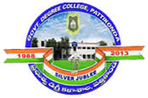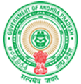**Government Degree College**

**ACCREDITED BY NAAC WITH ‘B’ GRADE Pattikonda,Kurnool (Dt),A.P.518380.**

**Dr R Madhuri,**

**Principal ,**

**Financial Management and Resource Mobilization**

**Institution conducts internal and external financial audits regularly enumerate the various internal and external financial audits carried out during the year with the mechanism for settling audit objections**

**The college has both internal and external audit mechanism. The college being a Government institution carries out financial transactions as per the guidelines of state government, University Grants Commission and the other funding Agencies.**

**The accounts of the College are audited annually by the Audit of the Government of A.P. There are no major audit objections. However, every month the accounts are reconciled with Treasury figures. If there are any deviations the mistakes are rectified immediately. The expenditure regarding salary bills, students strength, admission process, leave on duty register, purchase process, utilization of special fee, tuition fee etc., will be examined. After the completion of financial year, the Utilization of UGC funds, Special Fee funds are audited by audit team from Commissioner of Collegiate Education.**

**The government funds are audited by the team from the office of the Accountant General of Andhra Pradesh. At the end of every year the financial statements get audited by local auditor. The Government of Andhra Pradesh has framed the audit mechanism for all the Government educational institutions.**